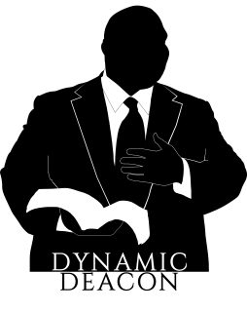
Deacon Harold Burke-Sivers – known around the world as the “Dynamic Deacon” – is one of the most sought-after speakers in the Church today. He is a powerful and passionate evangelist and preacher, whose no-nonsense approach to living and proclaiming the Catholic faith will challenge and inspire those who hear him.

He travels across the United States and around the world speaking at conferences, workshops, retreats, parish missions, high schools, and young adult events – in short, to everyone who desires to know Jesus intimately and enjoy a deeper personal relationship with Him. His areas of expertise include marriage and family life, discerning the will of God, the sacraments, male spirituality, evangelization, prayer, and many others.

Deacon Harold holds a Bachelor of Arts Degree in Economics and Business Administration from the University of Notre Dame, and a Master of Theological Studies Degree from the University of Dallas. He co-hosts the Eternal Word Television’s Network’s popular radio program “Morning Glory”, and the national weekly broadcast “Living Stones” on Mater Dei Radio.

In addition, he is the host or co-host of several popular series on EWTN television and is featured on the award winning Chosen faith formation program by Ascension Press. Deacon Harold is the author of the best-selling book, Behold the Man: A Catholic Vision of Male Spirituality, co-author of Ignite: Read the Bible Like Never Before, and has written the acclaimed book, Father Augustus Tolton: The Slave Who Became the First African-American Priest.

Retaining a deep love of Benedictine spirituality which he gained during his time discerning a call to that religious community, Deacon Harold is a Benedictine Oblate of Mount Angel Abbey. He is also a member of the Fellowship of Catholic Scholars and the Confraternity of Catholic Clergy.

Most importantly, he is married and has four beautiful children. They live in Portland, Oregon, where Deacon Harold is assigned to Immaculate Heart Catholic Church.

